VySkan
Product Name | 4G Advanced Fleet Telematics Terminal
Product Model | VF90-Hub
Precision. Expandability. Seamless Integration.
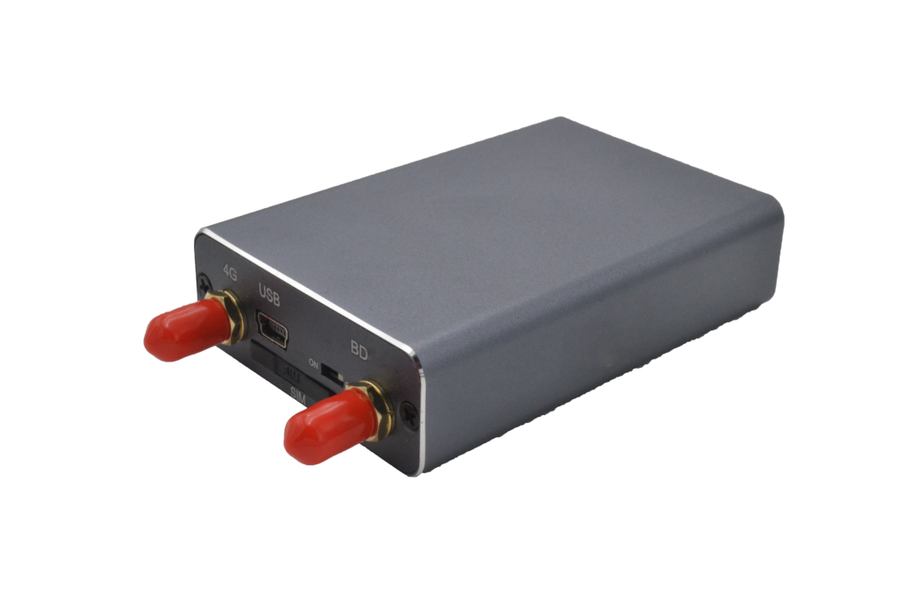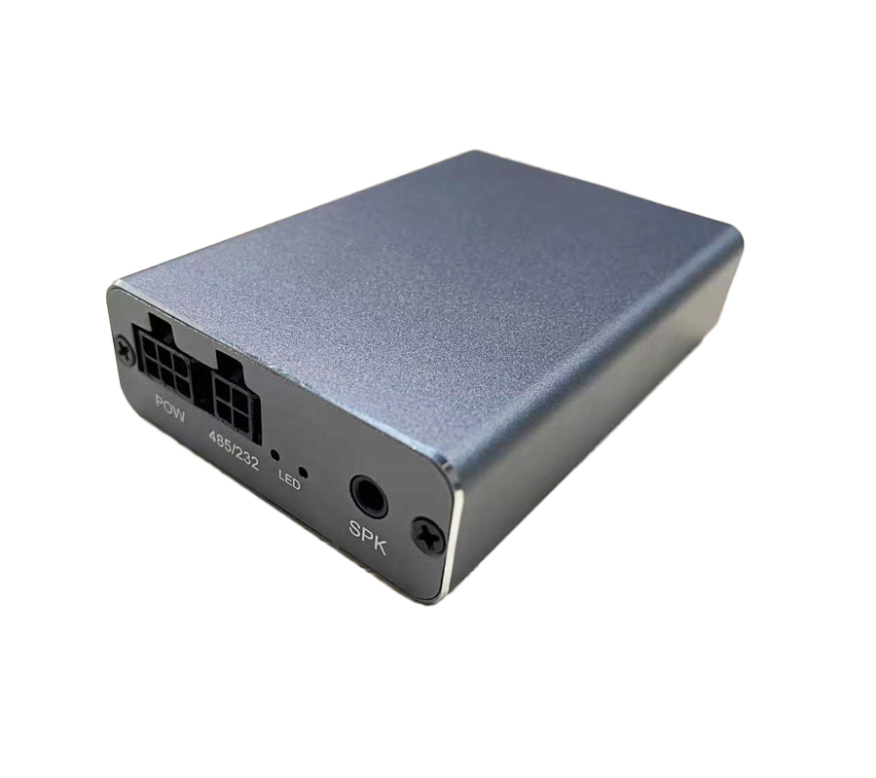
Engineered for logistics, construction machinery, and enterprise fleets, the VF90-Hub is a highly versatile 4G LTE tracking terminal. It bridges the gap between precise GNSS tracking and deep operational telemetry by offering ultra-wide voltage compatibility and seamless integration with fuel, payload, and environmental sensors, solving critical blind spots in asset monitoring.

Core Value
- Limitless Sensor Expandability
Go far beyond basic dot-on-a-map tracking. The VF90-Hub supports seamless integration with external fuel sensors, temperature/humidity probes, and payload weight sensors, transforming raw telemetry into actionable cost-saving insights.
- Ultra-Wide Voltage & Active Defense
Featuring an expansive DC 9V-90V operating range, it perfectly adapts to everything from passenger cars to heavy-duty industrial trucks. Remote fuel/power cut-off capabilities and instant power-loss alerts ensure your assets are guarded 24/7.

- Zero Data Loss Guarantee
Never lose a track due to network dead zones. The built-in large-capacity flash memory automatically caches up to 10,000 historical records during signal drops and seamlessly uploads them upon reconnection, ensuring 100% route integrity.

Target Applications
- Logistics & Freight Transportation (Fuel & Payload Monitoring)
- Construction & Heavy Machinery (Asset tracking & wide-voltage support)
- Cold Chain Logistics (Temperature & Humidity sensing)
- Car Rental & Auto Finance (Remote immobilization & anti-theft)
- Technical Specifications
  - Cellular & GNSS
Category | Specification | Description
Network Bands | 4G FDD-LTE: B1/B3 | 4G TDD-LTE: B38/B39/B40/B41 | Reliable 4G Full Netcom coverage for uninterrupted data transmission.
Comm. Protocol | JT/T 808 (TCP/IP) | Industry-standard protocol for rapid third-party platform integration.
GNSS Module | GPS + BDS Dual-mode | High-performance tracking with AGPS support.
Positioning Accuracy | <5m CEP (open sky) | Pinpoint precision for real-time asset visibility.
Sensitivity | -165 dBm | Maintains lock in challenging and dense urban environments.
OTA Support | TFTP Remote Upgrade | Supports remote parameter configuration and over-the-air firmware upgrades.
  - Power & Electrical
Category | Specification | Description
Operating Voltage | DC 9V - 90V | Ultra-wide voltage range compatible with light and heavy-duty vehicles.
Standby Current | < 50 mA | Low power consumption to protect the vehicle's battery.
Backup Battery | 180 mAh / 4.2V Li-ion | Triggers main power-loss alarms for active anti-theft defense.

  - Interfaces & Expandability
Category | Specification | Description
Ignition Detection | ACC ON/OFF | Real-time monitoring of vehicle start/stop status.
Immobilization | Remote Cut-off | Remote engine stop/restore capability via external relay.
Fuel Monitoring | Sensor Supported | Integrates with external fuel sensors to monitor tank levels and prevent theft.
Temp/Humidity | Sensor Supported | Environmental monitoring tailored for cold chain operations.
Payload Sensing | Sensor Supported | Integrates with weight sensors to monitor cargo loads and prevent overloading.
  - Physical & Environmental
Category | Specification | Description
Dimensions | 80mm × 55mm × 20mm | Compact and modular design for covert installation.
Weight | 70g | Lightweight construction.
Operating Temp. | -20℃ to +70℃ | Reliable operation in varied climates.
Storage Temp. | -40℃ to +85℃ | Safe storage in extreme conditions.
Operating Humidity | 5% - 90% RH | Resilient in highly humid environments.

Built for Rapid Integration & Telemetry
We know hardware is only half the solution. The VF90-Hub is designed to drastically reduce your Time-to-Market (TTM) and development costs.
- Standard Protocols: Natively supports TCP/IP and the industry-standard JT/T 808 protocol.
- Supported Platforms: Seamlessly integrates with industry-leading tracking software including Wialon, Traccar, and enterprise custom dashboards without reverse engineering.
- Advanced Sensor Parsing: Comprehensive Open API documentation helps your IT team effortlessly parse not just GPS coordinates, but deep telemetry data (fuel, payload, temperature), achieving live dashboard connectivity in under 48 hours.

- A personalized service prepared for you
- 1× VF90-Hub Sample Device (Pre-configured)
- Full API & Protocol Documentation (JT808)
- 1-on-1 Technical Support from our Field Engineers
- Contact us
Website：https://vyskan.com/
Email: marketing@vyskan.com

