Veyloc
Product name | Smart health and security positioning wristband
Product models | VN-Health
Guard. Interconnected. No worries.
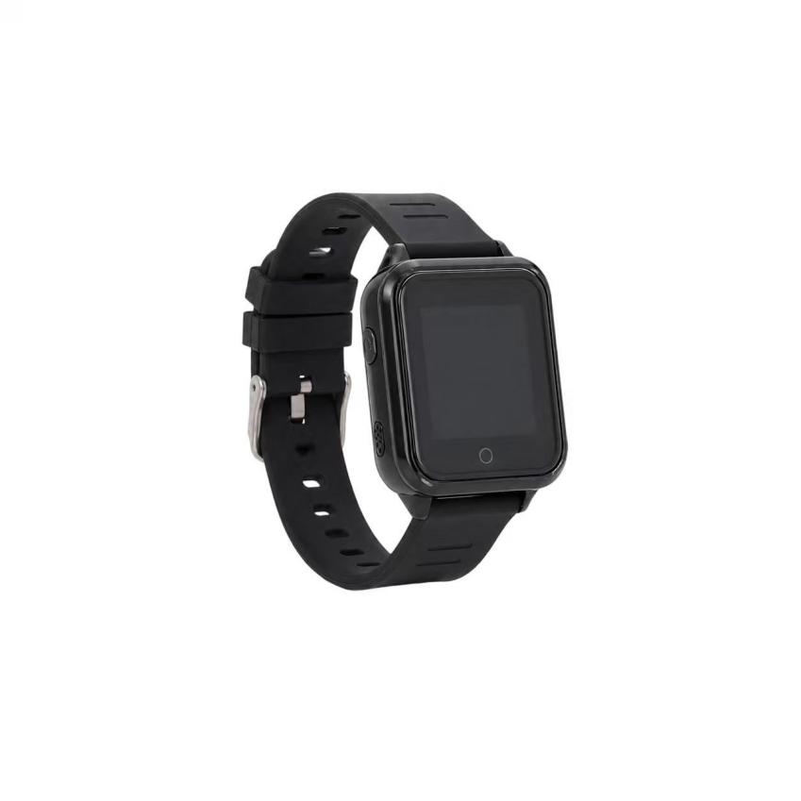
Veyloc VN-Health is an advanced wearable positioning terminal tailored for high-risk field operations and professional medical care scenarios. The device is equipped with the MT2503AE+MT5931 high-performance chipset, perfectly integrating six positioning technologies—GPS/BeiDou/WIFI/BLE, and medical-grade health sensors. Inside the robust body with IP57 water and dust resistance, it integrates a large 600mAh battery, SOS one-touch SOS call, and real-time two-way calls. Combined with a drop-resistant TPU strap, it is the ultimate all-weather safety line protecting vulnerable groups, outdoor workers in isolation, and elderly patients.
Core Value (核心价值)
Six-layer precise positioning without blind spots: Innovative integration of GPS, Beidou, LBS, WIFI, AGPS, and BLE Bluetooth positioning technologies. Whether the wearer is in a remote outdoor area or in complex indoor buildings (such as nursing homes or factories), the device can intelligently switch the optimal positioning source, completely eliminating positional blind spots.
Active health intervention and monitoring: Breaking the single-function traditional locator with built-in high-precision sensors (Tianyi Hexin), it collects the wearer's heart rate, blood pressure, and sleep data in real time. Upgrading "passive finding" to "active medical defense," it provides immediate warnings when vital signs are abnormal.
Rapid Life-Saving Channel: SOS physical buttons and two-way communication designed specifically for emergencies. In the event of an accident (such as a fall or sudden illness), the wearer can connect directly to the monitoring center or family with one click, and with millisecond-level pop-up alerts, the response time for emergency rescue is greatly reduced.
4. Target Applications (目标应用场景)
Smart elderly care and medical monitoring: (Comprehensive physical sign monitoring combined with virtual electronic fences provides hospital-level protection for patients without restricting their freedom of movement).
Isolated workers and industrial security: (IP57-level protection and one-click SOS call for help, providing reliable life-support channels for high-risk outdoor workers such as inspectors and miners).
Security for children and special groups: (Anti-drop alarm mechanism and Bluetooth 4.0 for precise indoor positioning ensure guardians always monitor the absolute safety trajectory of the person being supervised).
Technical Specifications (技术规格)
通信与定位 (Cellular & GNSS)
Category | Specifications | Description
Core chip | MT2503AE + MT5931 | High-performance dual-core architecture ensures absolute smooth data concurrency processing and voice transmission.
Communication frequency bands | GSM 900/1800MHz | Compatible with quad-band networks, providing stable and reliable wide-area cellular network coverage.
Positioning mode | GPS+BDS+LBS+WIFI+AGPS+BLE | Six positioning engines work together to provide precise coordinates seamlessly connecting indoors and outdoors.
Antenna technology | Built-in LDS (GPS+GSM) | Using laser direct forming antenna technology, optimal RF reception performance is achieved in an extremely small space.
电源与电气 (Power & Electrical)
Category | Specifications | Description
Battery capacity | 600 mAh | Packed into a compact wearable size with a large-capacity battery to ensure lasting power.
Battery life | About 150 hours | Combined with deeply optimized power-saving algorithms, daily charging frequency is greatly reduced.
Charging port | Magnetic 2-PIN | The no-plug magnetic design not only enhances waterproofing but also greatly facilitates elderly users with poor eyesight.
接口与扩展 (Interfaces & Expandability)
Category | Specifications | Description
Health sensing | Heart rate and blood pressure monitoring | Built-in high-sensitivity sensor array captures and transmits key physiological indicators from the wearer in real time.
Voice interaction | Two-way calls & voice micro-chat | Integrated high-definition microphone and speakers, supporting platform unidirectional monitoring and two-way emergency intercom.
Bluetooth 4.0 | BLE indoor expansion | Supports Bluetooth anti-loss notifications, indoor beacon positioning, and seamless connection to external Bluetooth blood pressure monitors/blood glucose meters.
物理与环境 (Physical & Environmental)
Category | Specifications | Description
Main unit size | 56mm × 32mm × 16.8mm | Ergonomically designed compact design with a built-in digital display providing time and battery information
Strap material | Shock-resistant TPU structure | Made from skin-friendly and extremely tough industrial-grade materials, effectively preventing accidental detachment during intense activity.
Alarm mechanism | Physical SOS button + fall detection alarm | Once the device leaves the wrist or presses the distress button, the platform instantly receives a high-priority alert pop-up.
IP protection rating | IP57 | It offers excellent dust and water resistance, easily handling daily handwashing and rain-ridden water scenarios.
Deployment & Integration (部署与集成)
Out-of-the-box and system-level integration: VN-Health supports tool-free rapid distribution and wearing. The device fully supports OTA online remote upgrades, and the management center can remotely issue electronic fences and configure contact whitelists. Through open and standardized API interfaces, high-frequency location data, SOS alert events, and charted health data (steps, heart rate, sleep) collected by the wristband can instantly connect to the HIS systems of major hospitals or the security scheduling SaaS platforms of large enterprises with zero technical barriers.
Exclusive services prepared for you
- 1 VN-Health test prototype (pre-configured and commissioned).
- Complete API and underlying communication protocol documentation
- One-on-one support from Veyloc's senior FAE engineers

官网: https://veyloc.com/
邮箱: contact@veyloc.com / support@veyloc.com

